Downloading Neo4j

Download neo4j desktop at: <https://neo4j.com/download/> 🡪 Press download

Fill in details for license agreement. Then press download

Copy activation key to clipboard, by pressing on this (Note keep this window open in case you end up losing the key somewhere before the next steps):

Once it has downloaded open the install program.

Setting up Neo4j Background

Press Next.

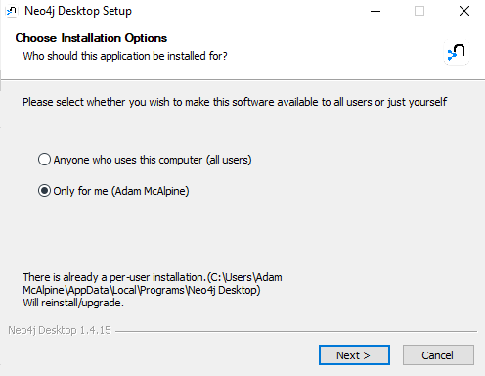

Then Press Install.

Make sure ‘Run Neo4j Desktop’ is checked, then press Finish

Upon launch you may be greeted with a firewall message clicking allow access will ensure the program runs properly.

Neo4J will then prompt you to accept its terms and conditions.

This should then prompt you for a path to install the program, the default path should be fine.

It should then load the application with this screen

You will then come to a registration stage where we will use the key we copied to the clipboard from the previous step into this box and click activate (Note if pasting the key doesn’t work for some

reason navigate back to the webpage we kept open and click copy to clipboard again).

d this should take you to the default loading screen. Press on new in the upper left, then press create project.

This should be the default new project template. Then go to the Add button on the top right, selecting local DBMS.

Once you’ve done that, this form should pop up. Fill in the details as specified bellow:

Name: database

Password: group43

Then press create.



Once created, it’ll appear as seen down below. Then press start.

Running the Web App

You’ll first need to open neo4j desktop, normally by searching your device for it.

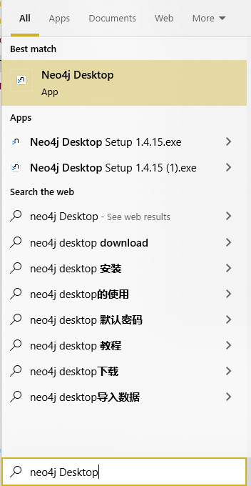

Once opened you’ll need to press the start button.

It might take a bit of time to run, but you’ll know it’s running once the database has an active sign next to it.

Now you are all good to open the web app.